[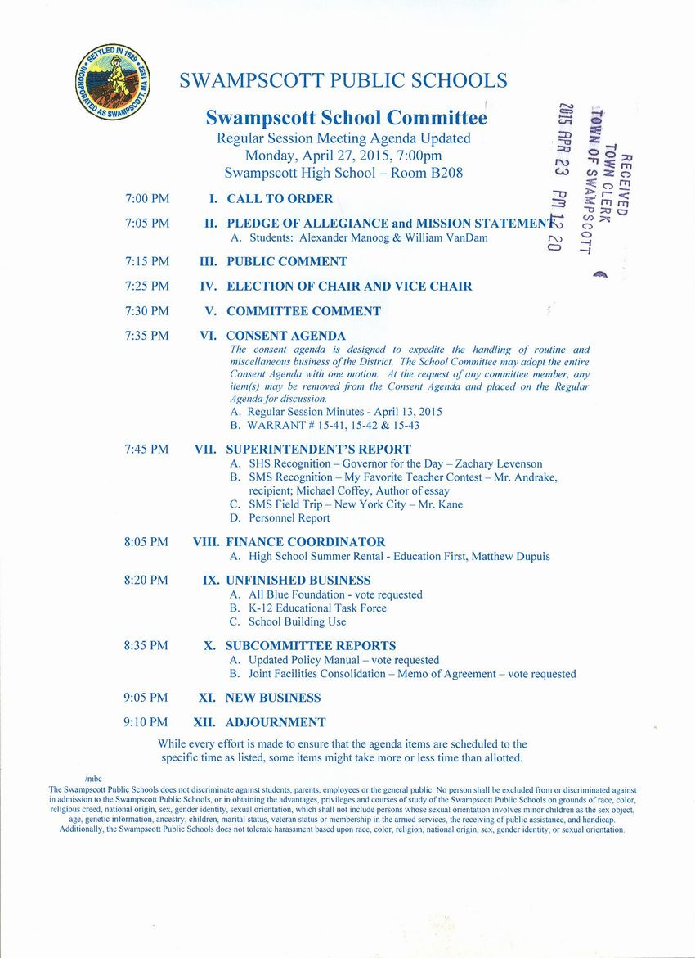](http://www.town.swampscott.ma.us/Public_Documents/SwampscottMA_Calendar/S04FBF814-05052913.0/SC%20April%2027th%20agenda%20001.jpg)